Angular Material UI – Overview & Real Example

* Angular Material is UI Component Library developed by the angular team that implements Google’s Material Design.
* It helps developers build consistent, responsive and modern –looking interfaces with minimal efforts

# **Why We Use Material UI?**

1. Pre-Build well tested UI Component
2. Responsive and accessible by Default
3. Follows Google’s Material Design
4. Works seamlessly with angular Forms, Routing, and RxJs.

# **How to Add Angular Material UI?**

* **ng add @angular/material**

During the Setup , You’ll choose:

* + A prebuilt theme (indigo/pink)
  + Whether to include Animations
  + Whether to use typography or global style

Reference Layouts:

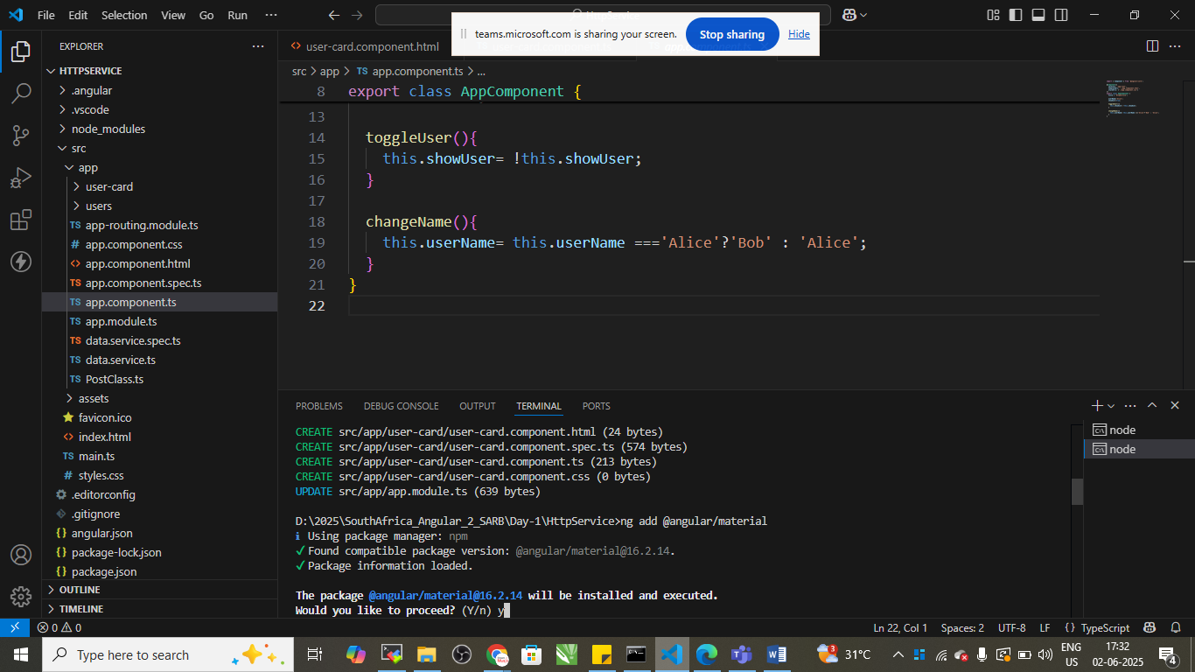

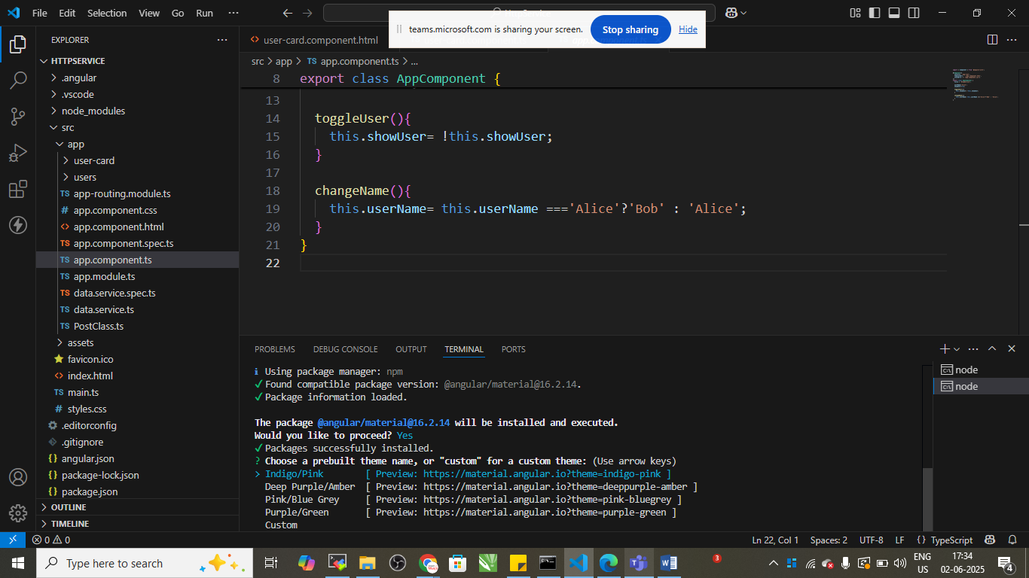

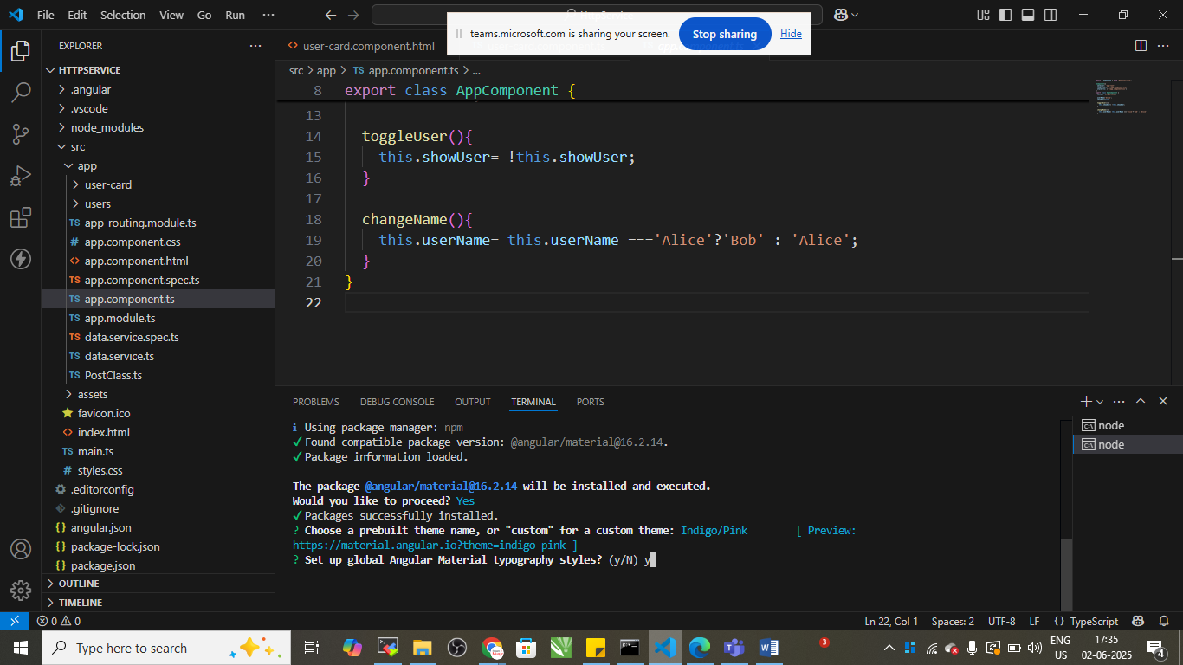

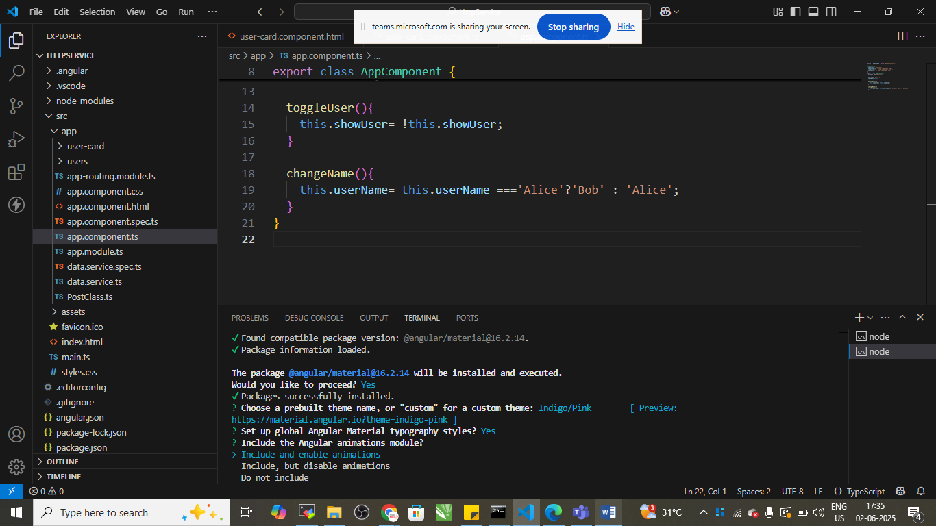

Define in app.module.ts file

import { NgModule } from '@angular/core';

import { BrowserModule } from '@angular/platform-browser';

import {HttpClientModule} from '@angular/common/http'

import { AppRoutingModule } from './app-routing.module';

import { AppComponent } from './app.component';

import { UsersComponent } from './users/users.component';

import { UserCardComponent } from './user-card/user-card.component';

import { BrowserAnimationsModule } from '@angular/platform-browser/animations';

import {MatProgressSpinnerModule} from '@angular/material/progress-spinner';

import {MatCardModule} from '@angular/material/card'

@NgModule({

  declarations: [

    AppComponent,

    UsersComponent,

    UserCardComponent

  ],

  imports: [

    BrowserModule,

    AppRoutingModule,

    HttpClientModule,

    BrowserAnimationsModule,

    MatCardModule,

    MatProgressSpinnerModule

  ],

  providers: [],

  bootstrap: [AppComponent]

})

export class AppModule { }

user.component.ts file

import { Component, OnInit } from '@angular/core';

import { PostClass } from '../PostClass';

import { DataService } from '../data.service';

@Component({

  selector: 'app-users',

  templateUrl: './users.component.html',

  styleUrls: ['./users.component.css']

})

export class UsersComponent implements OnInit {

  posts:PostClass[];

  loading=true;

  //dependency injection

  constructor(private service: DataService){}

  ngOnInit(): void {

    this.service.getAllPosts().subscribe(

      (data)=>{

        this.posts=data;

        this.loading=false;

      }

    );

  }

}

User.component.html

<div *ngIf="loading" class="spinner">

    <mat-spinner></mat-spinner>

</div>

<div *ngIf="!loading">

    <mat-card *ngFor="let p of posts" class="user-card">

        <mat-card-title>{{p.title}}</mat-card-title>

        <mat-card-content>

            <p><strong>UserId:</strong>{{p.userId}}</p>

            <p><strong>Id:</strong>{{p.id}}</p>

            <p><strong>Body:</strong>{{p.body}}</p>

        </mat-card-content>

    </mat-card>

</div>

You can add style to the component

User.component.style

.spinner{

    display: flex;

    justify-content: center;

    margin-top: 2rem;

}

.user-card{

    margin: 1 rem;

    background-color: aliceblue;

    padding: 10px;

    border: solid 5px royalblue;

}

Output:

